Experiment No: 05
Experiment Name: Implementation of Minmax Game playing Algorithm
Theory:
The Minimax algorithm is a decision-making algorithm used in Artificial Intelligence, mainly in two-player games such as Chess, Tic-Tac-Toe, and Checkers. It assumes that both players make optimal decisions. The algorithm uses a game tree consisting of MAX and MIN nodes, where the MAX player tries to maximize the utility value while the MIN player tries to minimize it.
The algorithm evaluates the game tree from the leaf nodes to the root node. At each MAX node, the highest value is selected, while at each MIN node, the lowest value is chosen. This process continues until the optimal utility value is determined at the root. In this experiment, the Minimax algorithm is implemented in C++ using a binary tree and recursion to find the best possible decision.
Objectives:
- To understand the basic concept and working principle of the Minimax algorithm in Artificial Intelligence.
- To implement the Minimax algorithm using C++ and a binary game tree.
- To understand how MAX and MIN players select optimal moves using recursive evaluation.
- To determine the optimal utility value and the best possible path in a game tree.

Source Code:

# include <bits/stdc++.h>
using namespace std;
struct Node{
int value;
bool isMax;

Node* left;
Node* right;
};
int minimax(Node* node)
{
if (node->left == NULL && node->right==NULL)
return node->value;
int leftVal= minimax(node->left);
int rightVal= minimax(node->right);

if(node->isMax)
node->value=max(leftVal, rightVal);
else
node->value=min(leftVal, rightVal);
return node->value;
}
int main()
{
Node* n= NULL;
Node L1= {-1, false, n, n};
Node L2= {8, false, n, n};
Node L3= {-3, false, n, n};
Node L4= {-1, false, n, n};
Node L5= {2, false, n, n};
Node L6= {1, false, n, n};
Node L7= {-3, false, n, n};
Node L8= {4, false, n, n};
Node D= {0, true, &L1, &L2};
Node E= {0, true, &L3, &L4};
Node F= {0, true, &L5, &L6};
Node G= {0, true, &L7, &L8};
Node B= {0, false, &D, &E};
Node C= {0, false, &F, &G};
Node A= {0, true, &B, &C};
int utility= minimax(&A);
cout<< "Utility = "<<utility<<endl;
cout<< "Path: A-> ";

if (A.value==B.value)
{
cout<< "B->";
if (B.value==D.value)
cout<<"D-> "<<D.value<<endl;
else
cout<<"E-> "<<E.value<<endl;
}
else
{
cout<<"C-> ";
if (C.value==F.value)
cout<<"F-> "<<F.value<<endl;
else
cout<<"G-> "<<G.value<<endl;
}
return 0;
}

Output:
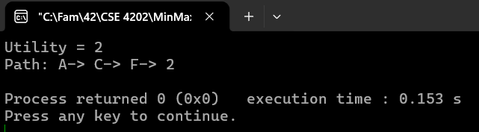

Discussion:
In this experiment, the Minimax algorithm was successfully implemented using C++ and a binary game tree. The algorithm evaluated eight leaf nodes by applying MAX and MIN operations at different levels. Through recursive calculations, the optimal utility value was found to be 2, with the selected path A to C to F to L5. This experiment helped in understanding how the Minimax algorithm selects the best possible move by considering both players' decisions. It also demonstrated the importance of recursion and game tree evaluation in Artificial Intelligence. Overall, the experiment successfully achieved its objectives.

